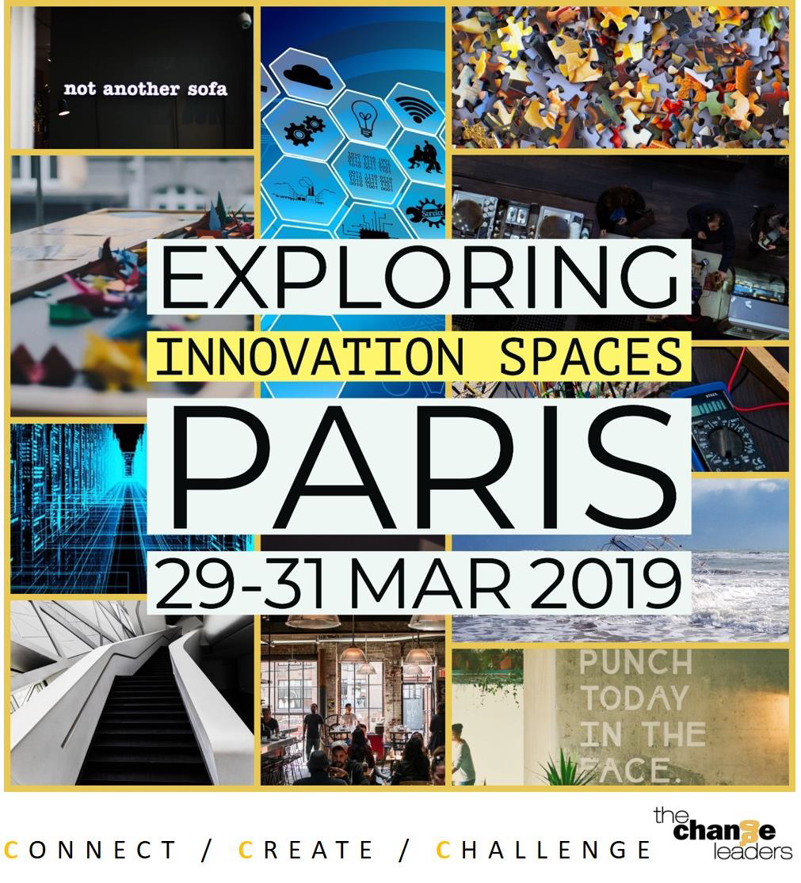

SESSION SUMMARY: SUNDAY MORNING
This summary recaps our Sunday morning discussion on “tCL as an Innovation Space.” Approximately 27 tCL members and 1 guest were in attendance.

The aim of the session was: “to discuss and brainstorm if and how tCL could or should become an ‘innovation space’. As a community of practice, tCL has been successful for nearly 14 years in building a community, sharing information and best practices, regularly holding two conferences a year, publishing the collected efforts of its members, and fostering networking at different levels among its members. Our community model is at steady state and we could continue in the same vein for the future. An alternative, or a complement, to the steady state is creating a space where innovation happens - innovation in business practices, in applying new frameworks, in creating new platforms, in using digital technology to foster creativity and change. If we choose to go this route, what would the ‘space’ look and feel like? How different would it be from our steady state? How would we have to organise? Can we do it on our own? Could we better leverage Oxford and HEC?” [from the program Conference Book]

The means used to process the discussion was a 90 minute World Café brainstorming session, with four topics and three rounds of conversations around these topics. For a presentation on the World Café method see the conference document on World Café.

An agenda consisted of the following:

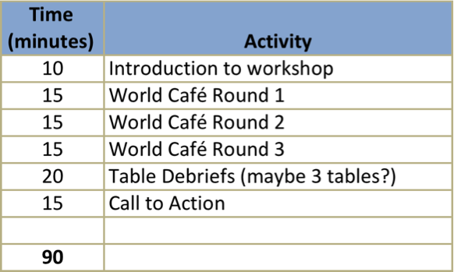

A brief introduction to the World Café was followed by conversations in small table groups of about 5-8 people. Each table was hosted by a facilitator (table anchor), and facilitators captured the main points discussed at their tables. Each table then debriefed with the assembly (roughly 28 people) by sharing a short summary of the table discussion. A few actions were agreed to by the assembly.

The topics, in the form of questions prepared by the Program Directors and session facilitator, were the following:

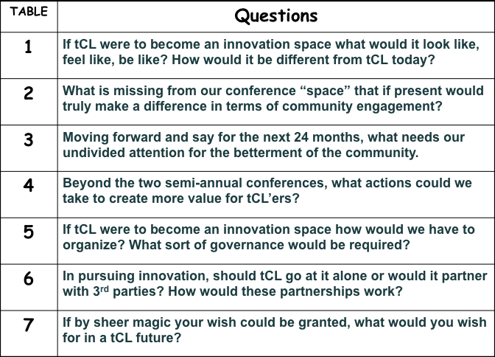

Given time constraints and the number of people in the assembly, the seven topics were whittled down to four via multivoting. Each assembly member assumed four votes, with these results:

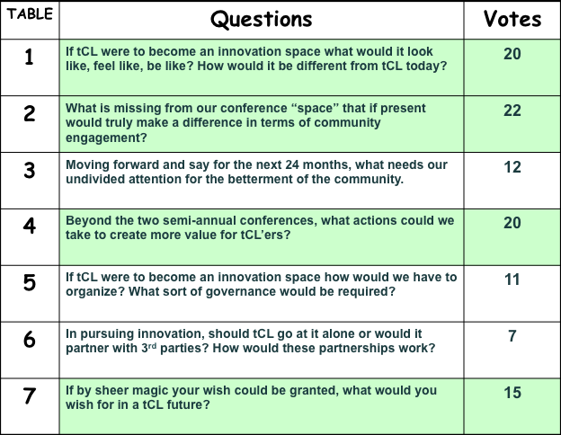

So, topics 1,2,4,and 7 received the most votes and were chosen for the discussion.

As summarized by each table host or facilitator, these are the ideas proposed by the group for each of the four topics.

Topic 1: If tCL were to become an innovation space what would it look like, feel like, be like? How would it be different from tCL today? [Lone]

- We need more outcome and more impact

- The outcome of the Change Leaders Community is limited, with the two conferences a year
- We talk, learn, and think, but do not do!
- Let’s start small and try different things
- Let’s be more experimental – both internally (within our own community) and externally (more interactions with others from the outside)
- Let’s pursue learning “outside the classroom”

- We need to define our Purpose

- What is our purpose, need discussion on that
- What unifies us – do we need to be unified?
- We should be more experimental, more like a lab, try out things with each other, and not only in class room format, we could create a platform for this

- Select the appropriate Governance Structure

- Are we fit for purpose – does it make sense the way we are set up, being such an international group?

- Can we “save the world?

- Engage with world issues, both on macro and micro plan
- We could collaborate with e.g. NGOs and use our different experiences to add value to the NGO and their work
- We could come up with our own project to “save the world”

- Is holocracy a model for our innovation space?

- Define different reasons for why we are together as a group – we do not need to agree on them all
- Have sub groups with their own purpose, everyone can choose the groups or spaces where they would like to be part of / can be more.
- Bring back learning and experiences from the sub groups to the bigger group

Topic 2: What is missing from our conference “space” that if present would truly make a difference in terms of community engagement? [Shekhar]

- We should practice: what we learn, more, together, and outside the conference
- Suggest we use the UN Conference/market-place model for our discussions - a good way to get all the knowledge in the room
- Each time we meet, we should work on a case and then follow up after the conference
- Bring issues/cases for a co-development space at the conference
- Devise formats and ways to have deeper conversations about change agent journeys, an aspect of CCC to be extended
- Let’s engage in peer coaching / mentoring
- We need to mix cohorts more during the conference
- We need to mingle more / walk and mingle
- Let’s include community participation in program choices and topics for the conference themes
- Replace brochure with an app… to hook up with people with each other
- Prior to the conference, a warm up could help via web meeting or conf call
- We could do something to follow up actions from the meeting - people focusing on different topics and then present
- Let’s have less density and more quality
- Explore the possibility of a joint conference with external parties
- Develop a horizontal storyline…e.g., one meta theme for a year
- Develop a strong purpose as an organization / meta topic
- Allow for different paths or group-work
- Would it be possible to webcast or record the conference?
- Let’s focus on an organization we can help, each time we meet; a live case study
- Let’s look into moving to other locations, for other cultures, a sort of learning expedition
- Let’s initiate case-clinics - bring an issue to the table
- Digital transformation: with a tCL app and better website
- Flip the classroom: consume the lecture prior to the conference - come here prepared to discuss, do hands-on work
- Use apps like Slack?
- Set conference dates and topics well in advance – at least one year in advance
- Need to do a better job of connecting people
- Let’s engage with corporate sponsors
- Keep the quality of the conference book, especially with listing participants and their LI links
- Need to have a recap/summary of the conference
- Need discussion with presenters on how we can use their tools in our practice (breakout/parallel sessions, rencontres interactiefs)

Topic 4: Beyond the two semi-annual conferences, what actions could we take to create more value for tCL’ers? [Rick]

- Share experiences we have working inside organizations
- Have a designed process for onboarding new tCLers
- Design a member retention process
- Speaker’s Corner: Keep connected to guest speakers. They are part of our community
- Be an open-system for sharing all things: content, ideas, challenges
- Structure idea: Assign people to support ideas generated in programmes so those are not lost.
- Allow for subgroups biased on interests
- More fun
- More knowledge access
- Access to the tCL network
- Generating/sharing process is needed
- Foster tCL as place of belonging
- Mentor and coach each other
- Sparing partners. This is to offer colliding perspectives
- Focus to help each other via peer to peer
- More social connection opportunities
- Maybe meet every two months like in CCC
- Hold virtual meetings that build and are built on trust, intimacy. Not webinars
- Build city chapters and share best practices in those places that work
- Share tCL/CCC list of people for networking
- Report back to conferences on work done outside that the group provided inputs to
- Books and articles by the community made easier to produce
- Podcasts by tCLers. Start small and grow it
- More SPREAD talks (tCL version of TED talks)
- Activate the old research/writing gathering before the start of tCL session (on Thursdays)
- Identify common interests and then organize into groups to share
- Kill What’s App group and break it into focused groups
- Consider using the app Slack
- Explore platforms for focusing discussions
- Define and determine the current value of tCL
- Understand “what happens between conferences.” Something is emerging. Seek it out
- Publish tools and processes that emerged after a conference
- Spread “what works” so it can be shared; how does tCL spread this stuff?
- Create Zoom communities based on trust and ground rules
- Set up innovation as a structure inside the community
- Where does innovation ideas go after the conference? Follow up
- Produce “what” for the outside world? That is, organize a collective voice to produce “something” for the outside world
- Develop joint commercial usage of tCL brand
- Offer fieldwork/pro-bono talent to the world

Topic 7: If by sheer magic your wish could be granted, what would you wish for in a tCL future? [Cyrille]

- Education: leverage common knowledge outside of tCL

- Build a branded 3-day tCL certificate on change
- Participate in talks and conferences as tCL representatives
- Become a source of reference for change, perhaps with an institutional affiliation

- Visibility/Marketing of the tCL brand: develop a brand image that is the reference point in terms of change

- Organize free workshops
- Formalize country units of tCL
- Develop marketing campaigns on themes/actions that could be monetized
- Develop ancillary products: books, videos, coaching, t-shirts, etc

- Service to others: build a network of professionals that can act on specific needs

- Develop an online workspace that could answer peer to peer questions (Ask tCL)
- Build a tCL blog with articles and Q&A, and suggestions for future articles
- Build and develop a platform of collaboration and visibility around change capabilities
- Become a change consultancy (LTD)

A few next steps were considered:

1.- Action: Document and distribute the output of the session (this document)

Responsible: Roberto

Due date: mid-April 2019

Status: The document will be part of the conference proceedings on the tCL website for member access.

2.- Action: Form an I-Team (Innovation Team) to data mine this document and delineate a course of action – Julia

Responsible: Julia

Due date: May 2019?

Status: The following tCL’ers volunteered to be part of the team: Mariann, Dirk, Lone, Rachel, Anna, Liora, Cyrille, and Severine. As a Board member, Julia will convoke the I-Team and decide how to organize.

3.- Action: Explore the implementation of I-Team recommendations and report back to general assembly.

Responsible: tCL Board

Due date: TBD

Status: Julia will serve as link to the Board, and present I-Team findings/ recommendations for Board discussion and action.

